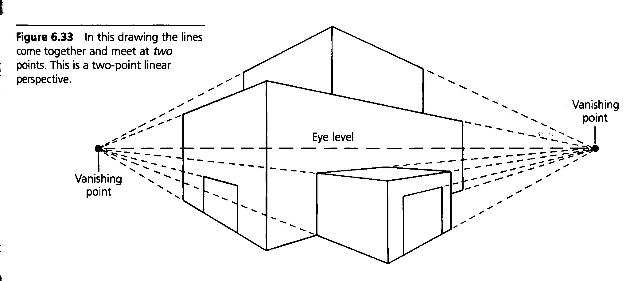Studio Art Perspective – 2 Point Rules

Two point perspective- from vertical line corners, all lines come together and meet at either a right or left vanishing point.

Vocabulary
A. Eye Level – horizontal line that is always even with your eyes.
B. Horizon Line – the actual or imaginary line that shows where land and sky meet (eye level and horizon line always appears as the same line).
C. Vanishing point – a point on the eye level line where parallel lines seem to meet.
D. Vertical –lines that are straight up and down.
E. Vertical Corner – any real or edge or an imaginary vertical that’s starts where 2 vanishing point lines meet.
F. Vanishing point line- a line drawn from the top and bottom of any vertical to the vanishing point.
G. Depth – the illusion of three-dimensional space, the illusion of looking into a flat space and seeing forms and distance.
H. Parallel- two lines equally distant from each other.

Rules – 2 Point Perspective

A. Start by drawing a vertical ( this is the corner that is closes to you ).
B. Every vertical (corner) has 2 lines to each vanishing point.
C. Every part of the box is made with four lines, two of each kind (top, bottom, left side, right side, back left, back right).
D. All lines in the drawing are either vertical (corners), left vanishing point or right vanishing point

